**ALihamza (213186)**

**Assignment no : 06**

**Activity: 01**

**Home Controller:**

using Microsoft.AspNetCore.Mvc;

namespace WebApplication7.Controllers

{

public class HomeController1 : Controller

{

public IActionResult Index()

{

return View();

}

}

}

**Index.cshtml :**

<html>

<head>

</head>

<body>

@model List<WebApplication7.Models.Product>

<ul>

@foreach(var product in Model)

{

<li>@product.Name</li>

}

</ul>

</body>

</html>

**Product.cs:**

namespace WebApplication7.Models

{

public class Product

{

public int ProductId { get; set; }

public string Name { get; set; }

public decimal Price { get; set; }

}

}

_**ViewStart.cshtml:**

@{

Layout = "_Layout";

}

**_Layout.cshtml:**

<!DOCTYPE html>

<html>

<head>

<meta name="viewport" content="width=device-width" />

<title>@ViewBag.Title</title>

</head>

<body>

<div>

@RenderBody()

</div>

</body>

</html>

**HomeController.cs :**

using Microsoft.AspNetCore.Mvc;

using System.Diagnostics;

using WebApplication7.Models;

using static WebApplication7.Controllers.ViewResult;

using static WebApplication7.Models.Order;

namespace WebApplication7.Controllers

{

public class ViewResult : Controller

{

private readonly ILogger<ViewResult> _logger;

public ViewResult(ILogger<ViewResult> logger)

{

_logger = logger;

}

public IActionResult Index()

{

return View();

}

public IActionResult Privacy()

{

return View();

}

[ResponseCache(Duration = 0, Location = ResponseCacheLocation.None, NoStore = true)]

public IActionResult Error()

{

return View(new ErrorViewModel { RequestId = Activity.Current?.Id ?? HttpContext.TraceIdentifier });

}

List<Product> products = new List<Product>

{

new Product

{

Name = "Mobile Phone",

Price = 50000

},

new Product

{

Name = "Tablet ",

Price = 100000

},

new Product

{

Name = "Laptoop",

Price = 80000

},

};

}

Order order = new Order();

order.Products Products;

order.Total Products.Sum(product => product.Price);

return View(order);

}

**ErrorViewModel.cs :**

namespace WebApplication7.Models

{

public class ErrorViewModel

{

public string? RequestId { get; set; }

public bool ShowRequestId => !string.IsNullOrEmpty(RequestId);

}

}

**Order.cs:**

namespace WebApplication7.Models

{

public class Order

{

public int orderId { get; set; }

public List<Product> products { get; set; }

public decimal total { get; set; }

internal class Products

{

}

}

}

**Index1.cshtml:**

<html>

<head>

</head>

<body>

@model List<WebApplication7.Models.Product>

<ul>

<tr>

<th>

Product Name

</th>

<th>

Price

</th>

</tr>

@foreach(var Product in Model.Products)

{

<tr>

<td>@Product.Name</td>

<td>@Product.Price</td>

</tr>

}

<tr>

<td><b>Total</b></td>

<td>@Model.Total</td>

</tr>

</ul>

</body>

</html>

**Activity: 02**

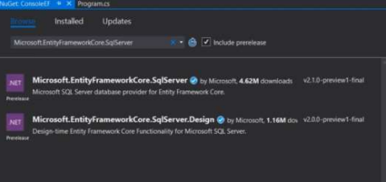

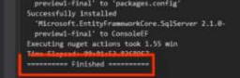



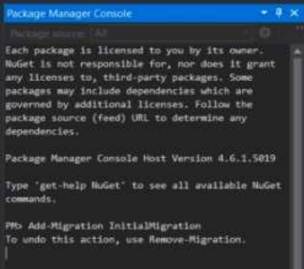

**Code:**

using System;

using System.Data;

using System.Data.SqlClient;

class Employee

{

public int EmployeeId { get; set; }

public string EmployeeName { get; set; }

public decimal Salary { get; set; }

public string Description { get; set; }

}

class Program

{

static string connectionString = "YourConnectionStringHere"; // Replace this with your actual connection string

static void Main()

{

// Example usage:

// Create an employee

Employee newEmployee = new Employee

{

EmployeeName = "John Doe",

Salary = 50000,

Description = "Senior Developer"

};

int newEmployeeId = CreateEmployee(newEmployee);

// Update an employee

newEmployee.EmployeeId = newEmployeeId;

newEmployee.Salary = 60000;

UpdateEmployee(newEmployee);

// Delete an employee

DeleteEmployee(newEmployeeId);

}

static int CreateEmployee(Employee employee)

{

using (SqlConnection connection = new SqlConnection(connectionString))

{

string query = "INSERT INTO Employees (EmployeeName, Salary, Description) VALUES (@Name, @Salary, @Description); SELECT SCOPE_IDENTITY();";

SqlCommand command = new SqlCommand(query, connection);

command.Parameters.AddWithValue("@Name", employee.EmployeeName);

command.Parameters.AddWithValue("@Salary", employee.Salary);

command.Parameters.AddWithValue("@Description", employee.Description);

connection.Open();

int newEmployeeId = Convert.ToInt32(command.ExecuteScalar());

return newEmployeeId;

}

}

static void UpdateEmployee(Employee employee)

{

using (SqlConnection connection = new SqlConnection(connectionString))

{

string query = "UPDATE Employees SET Salary = @Salary WHERE EmployeeId = @EmployeeId";

SqlCommand command = new SqlCommand(query, connection);

command.Parameters.AddWithValue("@Salary", employee.Salary);

command.Parameters.AddWithValue("@EmployeeId", employee.EmployeeId);

connection.Open();

command.ExecuteNonQuery();

}

}

static void DeleteEmployee(int employeeId)

{

using (SqlConnection connection = new SqlConnection(connectionString))

{

string query = "DELETE FROM Employees WHERE EmployeeId = @EmployeeId";

SqlCommand command = new SqlCommand(query, connection);

command.Parameters.AddWithValue("@EmployeeId", employeeId);

connection.Open();

command.ExecuteNonQuery();

}

}

}